Assignment-7

Assignment 7: Create a script that takes a text file and replaces all occurrences of

"old_text" with "new_text". Use sed to perform this operation and output the result to a new file.

Shell script code with the name of replace_text.sh:
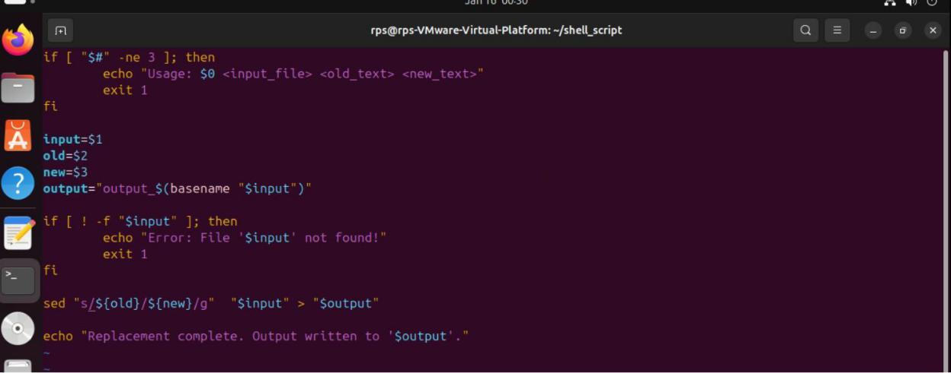

Commands to run replace_text.sh and checking its function:
